**30/06/2014**

### [1)Added convenience for parcels at Royal Mail part of agenda for growth](http://www.uniglobalunion.org/news/added-convenience-parcels-royal-mail-part-agenda-growth)

**﻿2)[Canada pilots same-day parcel delivery](http://www.uniglobalunion.org/news/canada-pilots-same-day-parcel-delivery)**﻿

**3)[Swiss Post launches YellowCube all-in-one e-commerce logistics](http://www.uniglobalunion.org/news/swiss-post-launches-yellowcube-all-one-e-commerce-logistics)**﻿

### [4)Japan Post innovates to serve its senior citizens ... and babies](http://www.uniglobalunion.org/news/japan-post-innovates-serve-its-senior-citizens-and-babies).

Click the above link to see details﻿

**28/06/2014**

**1)Our Federation addressed a letter to the Secretary on CBS issues copy of the letter published in sentinel.**

**2) Grant of Honorarium to Inquiry Officers (IO) / Presenting Officers (PO) for conducting inquiry in departmental proceedings would be outside the purview of the general delegation under FR 46 B – Such Honorarium is not limited to Rs. 5000 ﻿**

[**Click here to see the order.﻿**](http://www.fnpo.org/yahoo_site_admin/assets/docs/honur.178115405.docx)

**27/06/2014**

[**1)The world’s largest postal network wants to become a bank—and it should**](http://http/qz.com/223181/the-worlds-largest-postal-network-wants-to-become-a-bank-and-it-should/%20)

[**﻿Click this link to see detail**](http://www.fnpo.org/yahoo_site_admin/assets/docs/india_post.177102950.docx)

2) **income Tax 2014-15 (Assessment Year 2015-16) – Salaried Women to get higher Income Tax Exemption Limit – media reports**

3) **Retirement issue is to be handled with social mindset – says Dr. Jitendra Singh** ﻿ ﻿

[**Click  this to see above in detail**](http://www.fnpo.org/yahoo_site_admin/assets/docs/income_Tax_2014.17794209.docx)

[4) **Issue of medicines to CGHS beneficiaries at the time of discharge from empanelled private hospitals** ﻿](http://www.fnpo.org/yahoo_site_admin/assets/docs/Issue_of_medicines_to_CGHS_beneficiaries_at_the_time_of_discharge_from_empanelled_private_hospitals.177100457.docx)

**cLICK THE ABOVE LINK TO SEE DETAIL**

**26/06/2014**

**1)***[Draft of JCM Memorandum to 7th CPC and Proposed Pay Scale](http://ncjcmstaffside.com/wp-content/uploads/2014/06/Memorandum-to-be-submitted-by-NCJCM-Staff-Side-24.06.2014.pdf" \t "_blank)*

**Click the above link to see detail**

**2) Classification of Posts in 7th Pay Commission – NC JCM Staff Side Suggestion.**

**3) NC JCM STAFF SIDE SUGGESTION ON HOUSE RENT ALLOWANCE**

4)**Demand to calculate House Rent Allowance based on Census 2011 should gain prominence**

**5)NC JCM Staff Side suggestion on Children Education Allowance**

6) **NC JCM Staff Side demanding five promotions in the service career**

7) **Should the GRADE PAY STRUCTURE continue in the 7th CPC too?**

8) **Suggestion on Transport Allowance by NC JCM Staff Side**

9) **Foreign Tour for CG Employees – Demanded by NC** JCM Staff Side

[Click here to see the above in detail](http://www.fnpo.org/yahoo_site_admin/assets/docs/Classification_of_Posts_in_7th_Pay_Commission.176113314.docx)

**25/06/2014**

**Proposed Pay Scales for Central Government Employees on implementation of 7th Pay Commission – National Council JCM**

**National Council JCM has released Proposed Pay Scales for Central Government Employees on implementation of 7th Pay Commission**

**National Council Joint Consultative Machinery Staff Side**

**PROPOSED PAY STRUCTURE** UNDER DISCUSSION

[**Click here to see the detail**](http://www.fnpo.org/yahoo_site_admin/assets/docs/Proposed_Pay_Scales_for_Central_Government_Employees_on_implementation_of_7th_Pay_Commission.17592114.docx)

[﻿](http://www.fnpo.org/yahoo_site_admin/assets/docs/Proposed_Pay_Scales_for_Central_Government_Employees_on_implementation_of_7th_Pay_Commission.17592114.docx)

[Click here to see the **Hindi Version** of this website.](http://translate.google.co.in/translate?hl=en&sl=auto&tl=hi&u=http://www.fnpo.org/)

[**Click here to see the Tamil Version of this website**](http://translate.google.co.in/translate?hl=en&sl=auto&tl=ta&u=http%253A%252F%252Fwww.fnpo.org%252F)

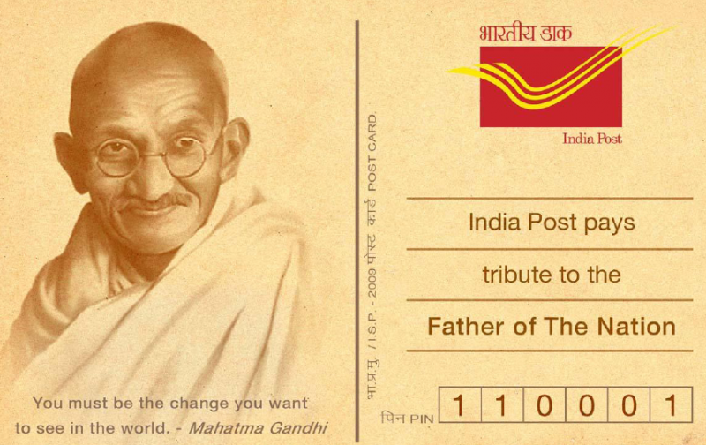

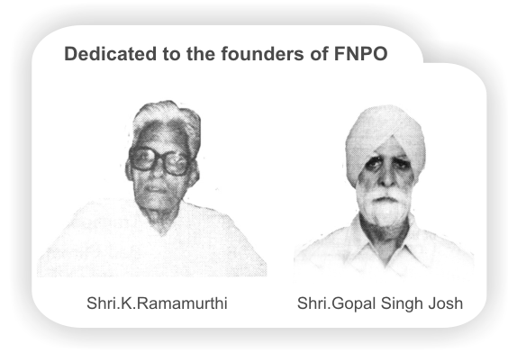

## Affiliated union websites:

[**National Association of Postal Employees Group 'C'**](http://nupegc.blogspot.com/)

[**NUPE Postmen & Group 'D'**](http://nupepostmenp4.blogspot.com/)

[**Nugdsfnpo.web.com**](http://www.nugdsfnpo.webs.com)

[**www.fnpocivilwing.blogspot.in**](http://www.fnpocivilwing.blogspot.in)

[**www.nupegckar.blogspot,com**](http://www.nupegckar.blogspot.com).﻿

[**www.fnpokerala.blogspot.com**](http://www.fnpokerala.blogspot.com)**.**﻿

[**napecjalandhar.blogspot.in**](http://www.napecjalandhar.blogspot.in/)

|  |
| --- |
| The Route with map, to any destination in the world by Air/Bus/Train Just click on link below and proceed further.  [**http://www.rome2rio.com/**](http://www.rome2rio.com) |

﻿

**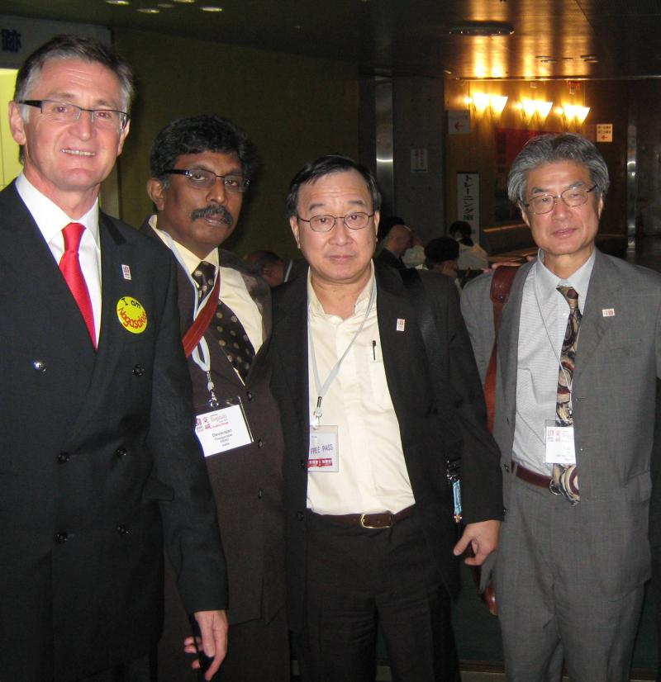**

|  |
| --- |
|  |

|  |
| --- |
|  |

**23/06/2014**

**1)Feedback of the meeting held between the Cabinet Secretary(Government of India) and Secretary(Staff Side), NC/JCM**

**A meeting was held today between the Cabinet Secretary(Government of India) and Secretary(Staff Side), National Council(JCM), wherein the undersigned raised the issue of non-holding of meeting of the NC/JCM since more than last four years.**

**While emphasizing on improvement in functioning of JCM Forum, I demanded effective functioning of the National and Departmental Council(JCM) at all levels.**

**I raised the issue of non-consultation with the Staff Side while deciding Terms of Reference of VII CPC on the back of Staff Side.**

**I demanded inclusion of issue of Merger of Dearness Allowance with Pay and Payment of Interim Relief should either be settled by the Central Government or it should be referred to VII CPC with specific instructions that, it should be deliberated immediately, and the issue of Interim Relief must be decided within three months.**

**I also raised the issue of rumour spread in the air for bringing 5 days a week working to six days a week.**

**The Cabinet Secretary said, so far there is no proposal of five days a week working at the anvil.**

**Copies of the letters written by the undersigned to the Cabinet Secretary in connection with the above subjects are being enclosed herewith for ready reference.**

**The Cabinet Secretary discussed all these issues and heard viewpoint of the Staff Side very patiently and assured that he would try to hold meeting of the National Council(JCM) at an earliest.**

**So far as merger of DA with Pay and Payment of Interim Relief are concerned, Cabinet Secretary assured for appropriate action.**

**He also assured for effective and smooth functioning of the JCM Forum .**

**Comradely yours,**  
**sd/-**  
**(Shiva Gopal Mishra)**﻿

[2)Payment banks cannot launch other financial operations](http://www.business-standard.com/article/finance/payment-banks-cannot-launch-other-financial-operations-114061600907_1.html)

Focus to be on unbanked areas; initial capital set at Rs 100 cr; India Post can apply

**﻿Click the above link to see detail news**

*21/06/2014*

**Victory for RR candidates**

**Madras High court dismissed the  WP no16041/2012 filed by the Tamilnadu circle administration against the CAT judgment in o.A 1072/2012) which was filed by sri A.V.Damadaran and 87 candidates .**

**L et us hope Tamilnadu circle administration will honour judgment of the  Madras High court without going on further appeal. It is pertinent to note that the FNPO is always backing the case of RRR candidates in every stage** ﻿

**20/06/2014**

**Reducing Delays in First Payment of Pension – Submission of Undertaking along with Pension Papers – Issue of PPO on the Date of Retirement – Reg**

[**Click here to read more**](http://fnpo.org/yahoo_site_admin/assets/docs/Government_of_India.170105917.docx)

﻿

**19/06/2014**

**1)Personal Income Tax Exemption Limit may be raised from Rs. 2 lakh to Rs. 5 lakh by New Government – CBDT to submit report on June 20th**

**2)LTC by air extended for 2 more years to Jammu and Kashmir and North East**

**3)Government employees who have differently abled children will be exempted from transfer – Dopt Orders**

**4)General Budget 2014-15: NFIR Presents list of proposals to be considered**

[**Click here to see above in detail**](http://fnpo.org/yahoo_site_admin/assets/docs/Personal_Income_Tax_Exemption_Limit_may_be_raised_from_Rs.169112014.docx)

5**)Dopt guidelines reg of complaints in Ministries\Departments**

[**CLICK HERE TO  SEE DETAILS**](http://ccis.nic.in/WriteReadData/CircularPortal/D2/D02ser/104_76_2011-AVD-I-18062014.pdf)

6) **change in the Nomenclature  of  Speed Post sorting hubs** [CLICK HERE TO SEE DETAILS](http://www.indiapost.gov.in/DOP/Pdf/Circulars/spe_rev_nomi_16062014_emai_pub_uploadl.pdf)﻿﻿

**14/06/2014**

**1)Five days a week working in administrative offices of the Central Government**﻿ **jcm staff  side secretary addresed the letter to The Cabinet SecretaryAndChairman National Council(JCM),**[**Click here to see the letter**﻿](http://fnpo.org/yahoo_site_admin/assets/docs/Five_days_a_week_working_in_administrative_offices_of_the_Central_Government.164151045.docx)

**2)CAT Madras stayed MTS Recurtiment .**

[**Clcik here to see details**](http://fnpo.org/yahoo_site_admin/assets/docs/mts_stay_order.16494649.png)

**13/06/2014**

**1)Raise Income Tax Exemption Slab to Rs. 5 Lakhs: NC JCM Staff Side**

**2)Regular Budget for the Financial Year 2014-15 is likely to be presented in July, 2014**

**3) Monitoring of the implementation of reservation policy for ESM in Central Government ﻿**

[**﻿Click here to see the details**](http://fnpo.org/yahoo_site_admin/assets/docs/Raise_Income_Tax_Exemption_Slab_to_Rs.163114535.docx)

﻿

**12/06/2014**

**1)LGO EXAMINATION FOR THE YEAR 2014 TO BE HELD ON 21ST SEP 2014**..

[**Click here to see the circular**](http://fnpo.org/yahoo_site_admin/assets/docs/lgo_exam.16292320.docx)

2) **Department of Personnel and Training mulls incentive plans for ministries, departments** ﻿

**Click below link to see detail**  [http://economictimes.indiatimes.com](http://economictimes.indiatimes.com/news/politics-and-nation/department-of-personnel-and-training-mulls-incentive-plans-for-ministries-departments/articleshow/36341592.cms) ﻿

**11/06/2014**

[***1)India Post to kick off sale of World Cup stamps***](http://timesofindia.indiatimes.com/india/India-Post-to-kick-off-sale-of-World-Cup-stamps/articleshow/36365640.cms)﻿

**Click the above link to see details**

**2) Delegation of Disciplinary/ Appellate Authorities in the CAT –regarding. ﻿**

[**CLICK HERE to SEE DETAILS .**](http://ccis.nic.in/WriteReadData/CircularPortal/D2/D02adm/A-12013_6_2011-AT-24102013.pdf)﻿

**10/06/2014**

**Trade unions meet Jaitely demand increase in minimum wage** [**click here to see details**﻿](http://fnpo.org/yahoo_site_admin/assets/docs/Trade_unions_meet_Jaitely_demand_increase_in_minimum_wage.160100819.docx)

**09/06/2014**

**Post offices can be information hubs, where one can submit all their requests, application forms, etc., and also receive the response from the same location for all their needs.**  
**Post office can be 24 pharmacies, medical stores, and can host teleconference facility with a doctor in city. This can enable medical facility to numerous villages of india that lack hospital but has a post office.** **please click below   links to see detail﻿**

[1)http://www.salon.com/2014/02/26/the\_post\_office\_can\_save\_america\_10\_ways\_postal\_banking\_can\_fix\_some\_of\_societys\_worst\_problems/](http://www.salon.com/2014/02/26/the_post_office_can_save_america_10_ways_postal_banking_can_fix_some_of_societys_worst_problems/)

-governance:  
  
[2)http://postandparcel.info/54402/news/it/polish-post-seeks-central-role-in-e-government-services/](http://postandparcel.info/54402/news/it/polish-post-seeks-central-role-in-e-government-services/)

[3)http://www.uspsoig.gov/story/risk-analysis-research-center-papers/e-government-and-postal-service-conduit-help-government](http://www.uspsoig.gov/story/risk-analysis-research-center-papers/e-government-and-postal-service-conduit-help-government)

[4)http://www.uspsoig.gov/blog/postal-service-your-connection-e-government](http://www.uspsoig.gov/blog/postal-service-your-connection-e-government)

**Any new startup or small company will require a supply chain system to deliver products or maintain contact with other branches or for day-to-day logistics. This back-end logistics can be cost effectively out-sourced to postal services.**  
  
[1)http://www.hongkongpost.hk/eng/sme/about/index.htm](http://www.hongkongpost.hk/eng/sme/about/index.htm)  
[2)http://www.hongkongpost.hk/eng/sme/complex/local/start/index.htm](http://www.hongkongpost.hk/eng/sme/complex/local/start/index.htm)  
E-commerce and trade:  
  
[3)http://postandparcel.info/61046/in-depth/can-e-commerce-save-the-post-office/](http://postandparcel.info/61046/in-depth/can-e-commerce-save-the-post-office/)  
[4)http://www.alizila.com/alibaba-invest-singapore%E2%80%99s-post-office-cross-border-push](http://www.alizila.com/alibaba-invest-singapore%E2%80%99s-post-office-cross-border-push)  
[5)http://www.wto.org/english/tratop\_e/devel\_e/wkshop\_apr13\_e/paul\_ponohoe.pdf](http://www.wto.org/english/tratop_e/devel_e/wkshop_apr13_e/paul_ponohoe.pdf)

**08/06/2014**

**FNPO** Congratulate **the   newly Elected Office Bearers of**

**National Union of Postal Employees, Postmen & Group ‘D’/MTS.**

[**Click here to see the list**](http://fnpo.org/yahoo_site_admin/assets/docs/List_of_newly_Elected_Office_Bearers_of.158153607.docx)**.** ﻿

**07/06/2014**

1) **Child Care Leave Clarification by DoPT: Removal of requirement of minimum period of 15 Days**

2) **Memorandum to VII CPC on merger of DA with Pay and Interim Relief**

3)**NFIR’s submission to 7th Pay Commission on Preliminary Inter-action meeting between NFIR and 7th CPC- NFIR calls for merger of DA with Pay along with other points**

[**Click here to see the above in detail**](http://fnpo.org/yahoo_site_admin/assets/docs/Child_Care_Leave_Clarification_by_DoPT.157125351.docx)

﻿ ﻿ ﻿

**04/06/2014**

**Today SGFNPO and General Secretary, AIPAOA (FNPO) submitted office bearer list to the Secretary, Department of Posts.**

**On 02.06.2014, 19th AIC of NUPM & MTS open session was held in Tirupati. The AIC was inaugurated by Chief Post Master General AP Circle. SGFNPO and General Secretaries of FNPO affiliated unions addressed the conference. Secretary, Department of Posts and Postal Board Members had sent their greetings to the conference.**

**On 03.06.2014 during the subject committee meeting Shri T.N.Rahate General Secretary placed biennial report and audited accounts . The house adopted the report and accounts unanimously. Other details will be posted in web site shortly.**

**On 04.06.2014 Brother Zakari Kodougou, Regional Secretary of UNI Africa visited India (Delhi). He proposed a visit to our Federation Office tomorrow (05.06.2014)  with his president.**

**01/06/2014**

**DA Merger with Pay – NFIR writes to Finance Minsiter for early implementation of Merger of 50% of Dearness Allowance in the pay of Central Government Employees﻿.**

**NFIR**

**National Federation of Indian Railwaymen**

**3, Chelmsford Road, New Delhi-**

**110 055**

**Affiliated to :**

**IndIan National Trade Union Congress (INTUC)**

**International Transport Workers’ Federation (ITF)**

**No.1/5(A)/Pt.I**

**Dated: 28/05/2014**

**Sh. Arun Jaitley**

**Hon’ble Minister for Finance,**

**Government of India,**

**North Block**

**New Delhi**

**Dear Sir,**

**Sub: Merger of Dearness Allowance with Pay-reg.**

**While enclosing copy of Federation’s letter No. 1/5(A) dated 27/09/2013, NFIR desires to bring to your kind notice, the following facts for consideration.**

**2. In the Standing Committee meeting held under the chairmanship of the Secretary DoP&T, on 7th May 2014, the agenda item pertaining to merger of D.A. with pay was discussed by the JCM/Staff Side representatives. There has, however, been no positive response from the Official Side on the issue probably the VII CPC has started working on the terms of reference.**

**3. Now that the D.A. has become 100% of pay w.e.f. 01/01/2014 and another installment of D.A. @ 6% of pay is likely to be granted by the Government w.e.f. 01/07/2014 as per the figures of Consumer Price Index, continuing D.A., without merger, is highly unjustified. In the past i.e. during the year 2004, the Government of India had merged 50% DA with pay for all purposes. Similar decision has, unfortunately, not been taken by the previous Government.**

**4. Seventh Central Pay Commission has already sent communications to JCM constituent organisations etc.. to submit Memorandums. At this juncture, it would be proper to convey to the Chairman, 7th CPC to consider the JCM (Staff Side) demand for merger of DA with pay with retrospective effect and send interim report to the Government for consideration.**

**NFIR, therefore, requests you to kindly consider our request and see that the Government makes reference to 7th CPC to consider DA merger with pay and to send its interim report to the Government for favourable consideration.**

**Thanking you.**

**Yours faithfully,**

**sd/-**

**(M.Raghavaiah)**

**General Secretary**

**Source: NFIR**

﻿

﻿