10/05/2013
﻿CWU members in Crown Post Office outlets are on strike for the third time Monday to protest Post Officeclosures.Read more...
09/05/2013.
Grant of ex service man status to Army Postal Service personnel. Click below link to see details
http://www.desw.gov.in/sites/upload_files/desw/files/pdf/DESW-﻿.
07/05/2013
19th AIC NUR-C
The 19th All India Conference of NUR-C was held in Raipur (Chhatisgarh State) from 3rd May to 6th May.
412 Delegates and equal number of visitors have participated in the conference . The Hon”ble Opposition leader Chhatisgarh state Shri Ravidra choubey formerly inaugurated and addressed the conference.
The General secretary welcomed the gathering.
B.M Agarwall Hon”ble Minister of Chhatisgarh State and Worshipful Mayor DR.Kiranmayee nayak Corporation of Raipur addressed the conference .
Secretary Department of Post ,all the Postal board members and 10 Chief postmaster generals sent their greetings to the conference. Shri Kulber singh Chief postmaster general and Director Shri Nirmal singh of Chhatisgarah state addressed the conference .
Rally : A colourful rally was organized by the Reception committee on 3rd May form Rammnath Bhimsen Bhwan to the Venue of the open session(SHAHID SMARAK BHAWAN)
The subject committee was presided over by Shri Subarato choudhry President NUR-C Biennial report was placed by General secretary was discussed, debated and passed unanimously without any amendments.
Policy and Prrogrammes : The AIC discussed National and International Scenario and present position of postal sector in other countries and based on that a Policy and programmes was adopted for the ensuing two years.
S/Shri Deepak Mukherjee, (W.B Circle) ,Subarato Choudhry (W.B circle ), D.Theagarajan, Pawan kumar joshi (Delihi Circle) were elected as President, working president, General secretary and Financial Secretary respectively.
Shri Sunil Kumar pandey and his team made a elaborate arrangements for conducting the conference in a grand manner. Our sincere thanks to the Reception committee.
Detail report of the conference will be published in our RMS SENTINEL.
BIENNIAL REPORT 2012-2013-
CLICK ABOVE LINK TO SEE THE REPORT APPORVED ﻿

Double Digit Returns on National Pension System (NPS) Schemes for Financial Year 2012-13
The National Pension System (NPS) regulated by Pension Fund Regulatory and Development Authority (PFRDA) has delivered double digit returns for the financial year 2012-13 and has evidenced itself as not just being the cheapest retirement product but also as the highest returns generating scheme.
PFRDA advises that various NPS schemes have earned the following average annual returns during the financial year recently ended on 31st March, 2013 (Weighted Average):
Details are as under:
Sr. No. | Scheme | Average returns (in %)
1 | Central Government | 12.39
2 | State Government | 13.00
3 | Swavlamban | 13.40
4 | Private: Equity | 8.38
5 | Private: Corporate Debt | 14.19
6 | Private: Government Debt | 13.52

Last year PFRDA had issued revised guidelines for Registration of Pension Fund Managers to manage NPS for Private sector, under which eight Pension Fund Managers have been registered so far- SBI Pension Funds Pvt. Ltd., UTI Retirement Solutions Ltd., LIC Pension Fund Ltd., Kotak Mahindra Pension Fund Ltd., Reliance Capital Pension Fund Ltd., ICICI Prudential Pension Funds Management Co. Ltd., HDFC Pension Management Co. Ltd. and DSP Black Rock Pension Fund Managers Pvt. Ltd.
Pension Fund Managers are now allowed to prescribe their own fee subject to ceiling of 0.25% to enable an economically viable model for their operations.
PFRDA also recently revised its Investment Guidelines, with a view to improve performance of Pension Fund Managers by direct investment in equity & corporate debt and not through mutual funds etc. Further for better risk management prudential sectoral norms have also been introduced.
The National Pension System which was introduced by the Central Government in January 2004 for its new entrants and subsequently extended to the private sector in May 2009 has accumulated a corpus of Rs 33,000 crores contributed by 50 lakhs subscribers.
Source: PIB

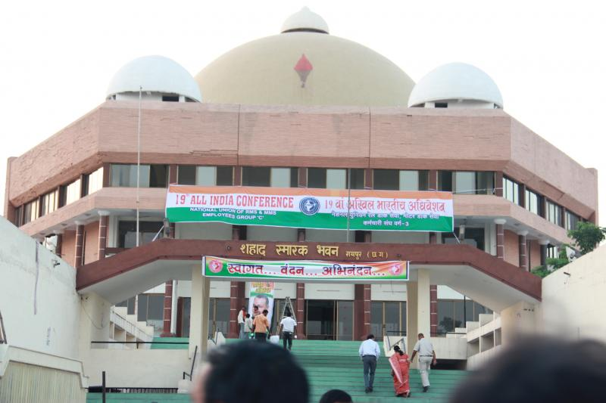
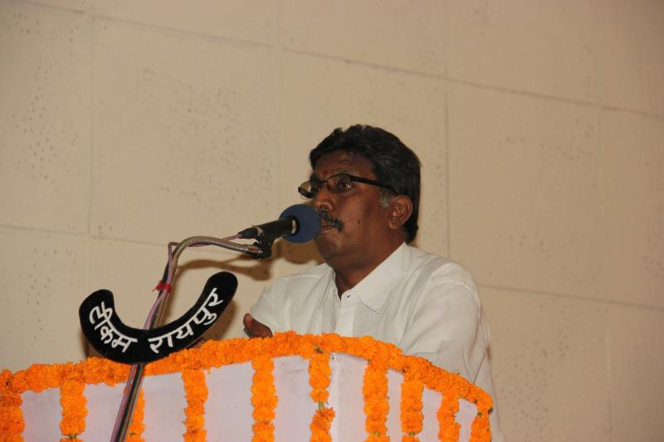
﻿﻿
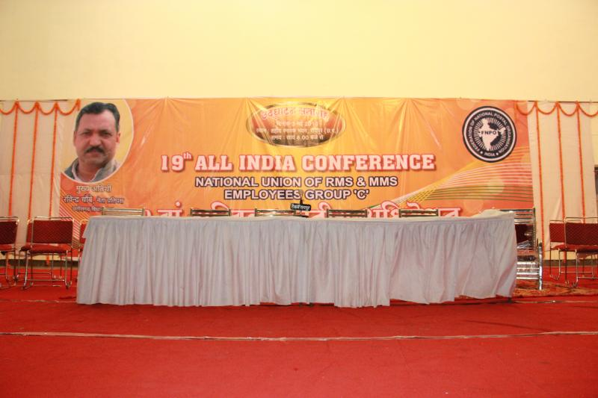
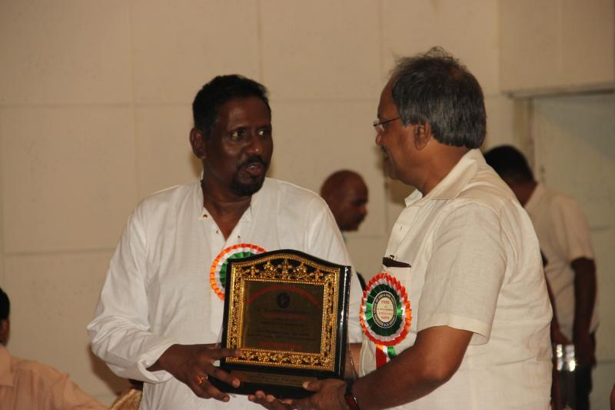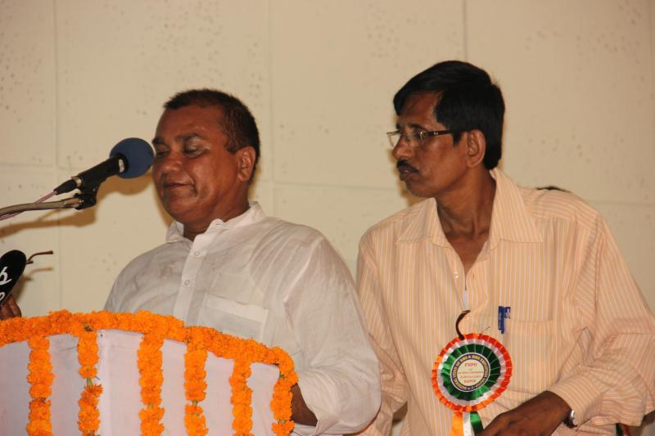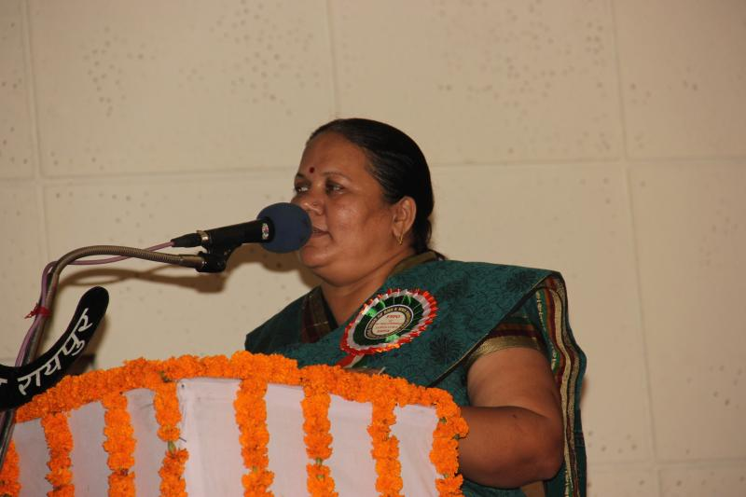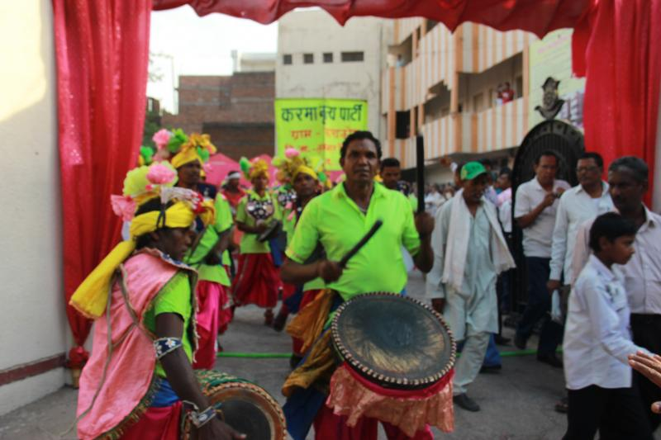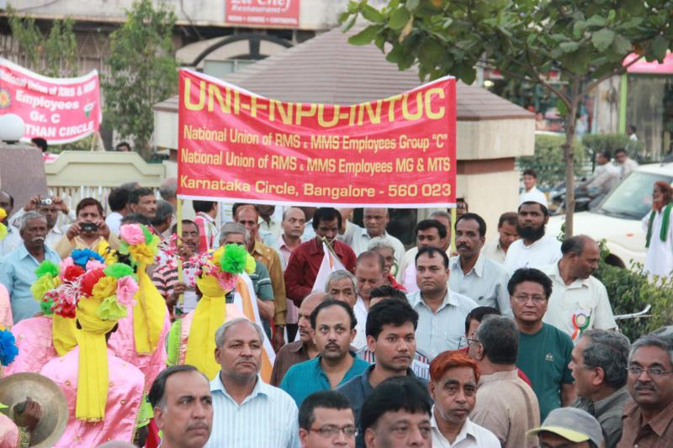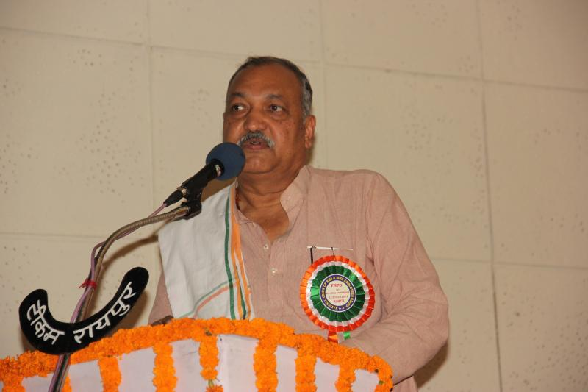
Click here to see the Hindi Version of this website.
FEDERAL WORKING COMMITTEE .
Our federal working committee and Seminar on “Chang Management will be held at Ahmadabad on 1st June &2nd June 2013 under the Presidentship of SriT.N.Rahate.
The following shall be the Agenda,
1)Change Management.
2)Post-Strike situation (20& 21).
3)Our stand on 50% DA merger / VII pay commission
4) Any other subject with the permission of the Chair.
The venue of working committee is Blind People Association / Andhajan Mandal
Vastrapur Near Gujarat University Ahmedabad-15.
For Lodging the below mention hotel is booked for Fwc members .
Hotel Khusabu,C G Road, ar Girish Cool drink
Ahmedabad-380009.
This is hotel is 15km from Airport
and seminarhallis 2km from hotel.
14/05/2013..
Dear colleagues read the below links and send your views to our Federation

Finance ministry opposes India Post’s banking licence plan.

Banks suppressing alerts on suspect dealings: RBI probe
12/05/2013
Click below link to see the news

Banker’s Trust | Why India Post should get a banking licence
If RBI wants financial inclusion, India Post, with its large customer base and branch network, is the fittest candidate.﻿
11/05/2013.
SG FNPO PROGRAMME
12/05/13 Pondicherry .
19/05/13 Tiruvannamalai
25/05/13to28/05/2013 Bhubaneswar.
29/05/2013 to 02/06/2013 Ahmadabad.﻿
10/05/2013
Transfer and posting order of JAG
Click here to see the order
﻿
﻿
29/05/2013
Plan Training activities for GDS under `Human Resource Development' - Reimbursement of Travelling, Board and lodging expenses etc.﻿
Click here to see the order
Introduction of "BAsic Savings Account" under post office savings Account Rule 1981 to facilitate opening of Zero Balance Accounts by benificiaries of any Govt. welfare scheme﻿
click here to see the order
28/05/2013
STAY GRANTED BY CAT (P.B) DELHI AGAINST ABOLITION OF POSTS OF POSTMEN & MTS.
Department of Posts ordered abolition of 17093 posts of various cadres. Out of which about 7500 posts were related to Postmen & MTS. AIPE Union Postmen & MSE/Gr. ‘D’ filed a case No. 1736/21.05.13 in CAT (P.B) Delhi along with NUPE Postmen & MTS and AIPEU GDS (NFPE). The Hon’ble CAT Delhi has granted stay against the abolition of posts of Postmen & MTS.
Next date of hearing is fixed as 11.6.2013.
Orders will be exhibited in web-site on receipt.
If there is any imposition of orders of abolition of posts in any Circle. They can take up the matter with the authorities concerned on the basis of CAT (PB) Delhi orders.
﻿ 28/05/2013﻿
22nd Bi-ennial Circle Conference of NAPE Gr-C Odisha Circle ﻿.
The Circle Conference of NAPE Odisha was held in Bhubaneswar at the auditorium of The Odisha Association for the Blind. The Conference was inaugurated by SG FNPO. The following addressed the conference.
Sri Soumya Rajan Pattnaik , Editor Sambad News Paper,
Sri D. Kishan Rao ,GS NAPE Gr-C,
Gautam Das ,AGS NUGDS,
Sri P.N. Mohapatra, President NUR Gr-C,
Sri Dasarath Das, President NUGDS Odisha Circle and Sri Rabindra Pattnaik, C/S NUR Gr-C.
Sri Damodar Misdhra C/S NAPE Gr-C placed Bi-ennial report in the subject committee meeting and initiated the debate and activities of the Circle union. Report was adopted unanimously after debate.
Sri Damodar Mishra, Was reelected as Circle Secretary. After the Circle Conference the team lead by SG FNPO & GS NAPE Gr-C met CPMG Odisha Circle along with Circle Secretaries of FNPO affiliated Unions and discussed the various issues.

27/05/2013
1. Issue of Due MAil & Sorting List consequent upon implementation of Redesigned Network for First Class and Second Class mail under Mail Network Optimization Project (MNOP)﻿
2. GRANT OF ONE INCREMENT IN PRE-REVISED PAY SCALE - OM DATED 19.3.2012 – CLARIFICATION
﻿Click here to see the details
Grant of Dearness Relief at the rate of 5th CPC w.e.f 01.01.2013﻿
Click here to see the details

25/05/2013.
The Union Cabinet today approved the Special Recruitment Drive launched to fill up the backlog in reserved vacancies of the Scheduled Castes (SCs), Scheduled Tribes (STs) and Other Backward Classes (OBCs). . Click here to see the details.﻿
24/05/2013.
National Pension System – KYC Documents required for entry and Exit of NPS click here to see the details
﻿Annual Increment denial to employees who retire after putting in more than Six Months of Service in the year of retirement – Government has no proposal to revise the policy –click here to see Minister replies in Rajya Sabha﻿
23/05/2013
Sri.G.K.Padmanabhan, Former SGFNPO is still under critical condition. Let us all pray for his speedy recovery.﻿
SGFNPO met member (P) and DDG (TRG) and discussed various issues of change management. Details will be published in RMS Sentinel.
22/05/2013
Promotion and posting to the Grade of Member, Postal Services Board, Indian Postal Service, Group'A'.﻿
Clic here to see the details

Dearness Allowance as Dearness Pay
click here to see the details
UPSC Civil Services Examination Answer Sheets can be viewed online soon
﻿Click here to see the details
20/05/2013
SHORTAGE OF STAFF IN POSTAL DEPARTMENT QUESTION NO 6875 ﻿in LOK SABHA ﻿by Smt.DARSHANA VIKRAM JARDOSH, ASHOK TANWAR﻿ & ANSWER ﻿ byDr. (SMT) KILLI KRUPARANI)
2)Extension of RTI web portal for online filing of RTI application
Click here to see the details of 1&2
19/05/2013.
SG FNPO PROGRAMME.
22/05 /2013 &/23/05/2013 NEW DELHI
25/05/13to28/05/2013 Bhubaneswar.
29/05/2013 to 02/06/2013 Ahmadabad.

8/05/2013..
FILLING UP THE POSTS OF POSTMASTER GRADE III IN POST OFFICE IN POSTAL CIRLCLES.
CLICK ABOVE LINK TO SEE THE DETAILS.
Prime Minister Manmohan Singh on Friday said some of the demands raised by the various central trade unions, for which they organised a nationwide general strike for two days in February, were in advanced stage of consideration of the government.Click below link to see the details ﻿
Demands of unions under study, says PM.﻿

﻿

17/05/2013..
CLICK BELOW LINK TO SEE THE DETAIL.
New Pension System status report as on May 7, 2013﻿﻿
STUDY GROUP REPORT ON ENHANCEMEN T FOR BONUS CELING FOR GDS.
The discussions by the GOM with the representatives of the Major Central Trade Unions is a continuous process and is scheduled next on 22.05.2013 to resolve the demands.
Revision of Income Criterion to exclude Socially Advanced Persons/ Sections (Creamy Layer) from list of other Backward Classes (OBCs)
The Union Cabinet today gave its approval for increase in the present income criterion of Rs. 4.5 lakh per annum for applying the Creamy Layer restriction throughout the country, for excluding Socially Advanced Persons/Sections (Creamy Layer) from the purview of reservation of Other Backward Classes (OBCs).
The new income criterion will be Rs. 6 lakh per annum. The increase in the income limit to exclude the Creamy Layer is in keeping with the increase in the Consumer Price Index and would enable more persons to take advantage of reservation benefits extended to OBCs in government services and admission to central educational institutions.
This would bring about equity and greater inclusiveness in society. The Department of Personnel and Training and the Ministry of Human Resource Development would issue necessary orders to this effect.
Source: PIB News
﻿
16/05/2013.
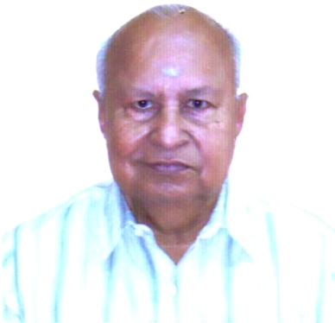
Our Former secretary-General Sri .G.K.Padmanabhan admitted in a hospital (Delhi) . Doctor informed that his condition is very critical. Let us pray Almighty for his recovery﻿.
Government has no proposal to waive Bonus ceiling.CLICK HERE TO SEE THE MOS REPLAY﻿
15/05/2013.
STATUS REPORT ON THE MEMORANDUM SUBMITTED TO THE SECRETARY DEPARTMENT OF POSTS BY POSTAL JOINT COUNCIL OF ACTION(PJCA).
Click here to see the details.﻿







